GAINING INSIGHT IN LINEAR PROGRAMMING
FROM PATTERNS IN OPTIMAL SOLUTIONS

“The purpose of modeling is insight, not numbers.”

Many of us have made a statement like this in the classroom when we teach basic linear programming. Some of us may even attribute the principle to Art Geoffrion, in which he actually referred specifically to mathematical programming. But he probably had predecessors. Geoffrion quotes Richard Hamming’s statement to the effect that the purpose of computing is insight. And I’ve been told that Albert Einstein said that the purpose of mathematics is insight. It all makes me think that perhaps Euclid might once have said that the purpose of geometry is insight. So, I doubt that the talk about insight is very new. Still, I find myself wondering: where is the insight, anyway? Specifically, when we teach linear programming, and we say that the real take-away from solving an LP model is insight, where exactly do we find it?
In this paper, I shall describe one form of insight, which comes from interpreting the qualitative pattern in an LP solution. Stated another way, the optimal solution tells a story about a pattern of economic priorities, and it’s the recognition of these priorities that provides insight. When we know the pattern, we can explain the solution more convincingly than when we simply read the algorithm’s output. When we know the pattern, we can also anticipate some of the answers to “what if” questions. In short, the pattern provides a level of understanding that enhances decision-making. Therefore, when we ask students to solve LP problems, we should also ask them to describe the qualitative pattern in the optimal solution.
Spotting a pattern involves observations about both variables and constraints. In the optimal solution we should ask ourselves, which constraints are binding and which are not? Which variables are positive and which are zero? Grasping the pattern of binding constraints and positive variables allows us to reconstruct the solution in a sequential fashion. To the untrained observer, we seem to be solving the problem with less effort than the simplex algorithm would require; but, in fact, we are only providing a retrospective interpretation of the solution, and we need to know that solution as a starting point. Nevertheless, there’s more here than just identifying the optimal basis: there is an opportunity to discern an economic imperative at the heart of the situation depicted in the model. When students can see that, then they have insight.
The next sections give some examples of patterns, show how to describe a pattern without using numbers, and provide two tests to determine whether the pattern has been identified. We'll see how ranges for shadow prices and reduced costs can be computed based on patterns. (These ranges help interpret the quantitative information in sensitivity analysis and reinforce the underlying economics in a solution.) Finally, keep in mind that, although the examples are relatively small, the process of identifying patterns is fairly general and also applies in much larger models.
The examples discussed here have been used in a required introductory-level MBA course in mathematical modeling, where linear programming is one of several management science topics covered. (The course does not always include all of the examples, but each example has been used at one time or another.) However, identifying patterns is an interpretive skill rather than an advanced mathematical skill; it can be covered in undergraduate courses or management development classes—wherever linear programming is taught.
Because my own teaching has emphasized spreadsheet-based modeling approaches, I will refer specifically to the use of Solver and the report it provides for sensitivity analysis (called the Sensitivity Report). Solver is one of many linear programming packages, but it is the most popular among end-users and one that is now emphasized in the top MBA programs. Comments about Solver apply to most common linear optimization software packages and to the reports they generate for optimal solutions and for sensitivity analysis.

A Transportation Example

In the classical transportation model, we are given supply quantities at several sources, demand requirements at several destinations, and we seek a least cost shipment schedule. In the example of Exhibit 1, there are three sources (A, B, and C) with supply quantities 70, 50, and 30, respectively, and there are five destinations (D through H), with requirements of 30, 24, 12, 42 and 6. These parameters, along with unit transportation costs for each route, are given in the upper table. The lower table gives the optimal shipment schedule, with a minimum total cost of $1018.
The first thing to notice is that we don’t need to use all of the available routes in order to optimize costs. (This comes as no surprise to anyone who has studied linear programming from the perspective of linear algebra, but it is worth pointing out explicitly to the novice problem-solver, for whom it may be counterintuitive.) As the optimal solution reveals, the best routes to use are AE, AG, BD, BG, BH, CD, and CF.
The model contains excess supply. Since unit costs are positive on all routes, we should expect that the optimal solution ships only enough to meet demands exactly; there is no incentive to ship more than demand to any destination. Another consequence of meeting all demands exactly is that at least one of the supply capacities will be underutilized in the optimal solution. (In our example, A is underutilized; the other sources send out their full capacities.) In general, there is no way to anticipate how many sources will be fully utilized and how many will be underutilized, so one useful feature of the optimal pattern is the identification of critical sources—those that are fully utilized. The critical sources correspond to binding (supply) constraints in the model. (In our example, B and C are critical.)
A noteworthy feature of the optimal schedule is that some demands are met from a unique source: demand at E is all met from A, demand at F is all met from C, and demand at H is all met from B. In some sense, these are high priority allocations; we can think of them as if they are made first. In other problems there can be a symmetric feature: supply may be shipped to a unique destination. This feature also marks a high priority allocation.
If we remove the high priority shipments and their demands from consideration, we are left with a reduced problem containing three sources and two destinations. Now, the list of best routes tells us that the remaining supply at C must go to D, since CD is a high priority allocation in the reduced problem. Thus, we know exactly which shipments leave C and where they go.
Having accounted for the allocation of the entire supply at C, we are left with a net demand at D, with only B still available (among the best routes) as a source. Given that we have removed C from consideration after allocating its entire supply, the remaining demand at D is all met from B. Now we can remove D from consideration.
We are left with just the demand at G. Since B is critical and BG is one of the best routes, the remaining supply at B must all go to G. This leaves a portion of demand at G unsatisfied; this portion must come from A.
Looking back, note that this description characterizes the optimal solution without explicitly using a number. By describing the optimal solution without using the parameters in the problem, we are portraying a qualitative pattern in the solution and articulating it as if it resulted from a list of economic priorities.
To review the steps in priority order, we have the following.

• List the best routes and critical sources.
• Identify a high priority demand—one that is met from a unique source—and remove this destination from consideration. Repeat if possible.
•. Identify a critical source with only one best route unallocated and allocate the remaining supply to this route. Then remove this source from consideration.
• Repeat the previous two steps using remaining demands and remaining supplies each time, until all shipments are accounted for.

This retrospective description of the solution has two important features: it is complete (that is, we can specify the entire shipment schedule) and it is unambiguous (that is, the description leads to just one schedule.) Anyone who constructs the solution using these steps should reach the same result.
The significance of this pattern is that it holds not just for the specific problem that we solved, but also for other problems that are very similar but with some of the parameters slightly altered. For example, suppose that demand at F were raised to 13. We could verify that the same pattern applies. Thus we know that the unit added to the demand at F will optimally be met from C, and therefore the direct cost due to the demand change is $6. However, when we allocate the marginal unit to the route CF, there is one less unit available to allocate to route CD. To compensate, we need to add a unit to route BD, remove one from BG, and add one to AG. Tracing down the “indirect” change in cost, we find that it comes to (–10+9–10+14) or $3. Thus, the change in the optimal total cost due to the unit increase in demand at F is $9. (This marginal cost is, of course, the shadow price on the demand constraint for F, but there is no mystery about where this value comes from if we understand the pattern in the optimal solution.)
As we trace the steps in this modified solution, we can also anticipate the range over which the shadow price holds. As we add units to the demand at F, the pattern induces us to make the same incremental adjustments in shipment quantities we traced above. The pattern of shipments will be preserved, and none of the best routes will be altered, as long as we add no more than 18 units to the demand at F. At that level, the shipment on CD disappears and we can no longer subtract from it. For an increase beyond 18 units, the set of best routes will change and therefore the pattern will shift to a different one.
More generally, we can “perturb” the original problem in several ways at once. Suppose demands at D, E, and F are each raised by one unit. What will the optimal schedule look like? In qualitative terms, we already know. The qualitative pattern of economic priorities allows us to write down the optimal solution to the revised problem without re-invoking Solver. Tracing the cost implications, we will find that the one-unit increases in the three demands will increase the optimal total cost by $29. This figure can be obtained by adding the three corresponding shadow prices, but the pattern allows us to take one additional step. We can also determine that the $29 figure holds for a change (in the three demand levels) of 16, which is the stage at which the allocation to BG runs out. Thus, we can find the range for a shadow price corresponding to simultaneous changes in several constraint constants. This is more complete information than we can obtain from the 100% rule, or from the typical sensitivity report.

A Product Portfolio Example

The product portfolio problem asks which products a firm ought to be making. If there are contractual constraints that force the firm to enter certain markets, then the question is which products we ought to be making in quantities beyond the required minimum. Consider Frosty Distributors, a company that distributes fifteen different vegetables to grocery stores. Frosty’s vegetables come in standard cardboard cartons that each take up 1.25 cubic feet in the warehouse. The company replenishes its supply of frozen foods at the start of each week and rarely has any inventory remaining at the week’s end. An entire week’s supply of frozen vegetables arrives each Monday morning at the warehouse, which can hold up to 18,000 cubic feet of product. In addition, Frosty’s supplier extends a line of credit amounting to $30,000. That is, Frosty is permitted to purchase up to $30,000 worth of product each Monday.
Frosty can predict sales for each of the fifteen products for the coming week. This forecast is expressed in terms of a minimum and maximum anticipated sales quantity. The minimum quantity is based on a contractual agreement that Frosty has made with a small number of retail grocery chains; the maximum quantity represents a conservative estimate of the sales potential in the upcoming week. The cost and selling price per carton of each of the products are known. The given data are tabulated in Exhibit 2.
Frosty solves the linear programming model shown in the exhibit, with an objective of maximizing profit for the coming week. Sales for each product are constrained by a minimum quantity and a maximum quantity. In addition, aggregate constraints on warehouse space and purchase expenditures make up the model.
When we look at the variables in the solution, we notice that all but one of the purchase quantities match either the maximum or the minimum. (Lima beans are the only exception.) Clearly, any product that has a nonzero minimum must appear in the solution at a positive amount, but some products are purchased at higher levels. These are high priority products.
When we look at the constraints in the solution, we see that the credit limit is binding, but the space constraint is not. In effect, the credit limit serves as a bottleneck on purchases. In other words, we are solving a knapsack problem: produce the highest possible value from the fifteen products under a tight credit limit. To solve this problem, we can use a common-sense heuristic: pursue the products in the order of highest to lowest value-to-cost ratio. (This heuristic is known to find the optimal value for the knapsack problem in the case of continuous variables.) The only proviso is that we must meet the given minimum quantities. Therefore, we can interpret the solution as follows.

• Purchase enough of each product to satisfy its minimum.
• Rank the products from highest to lowest ratio of profit to cost.
• For the highest ranking product, raise the purchase quantity toward its maximum quantity. Two things can happen: either we increase the purchase quantity so that the maximum is reached (in which case we go to the next product), or else we use up the credit limit (in which case we stop.)

The ranking mechanism prioritizes the products. Using these priorities, we essentially partition the set of products into three groups: a set of high-priority products, produced at their maximum levels; a set of low-priority products, produced at their minimum levels; and a single medium-priority product, produced at a level in between its min and max. (The medium-priority product is defined as the one we are adding to the purchase plan when we hit the credit limit.) This procedure is complete and unambiguous, and this pattern describes the optimal solution without explicitly using a number.
Again, we can perturb the base case model slightly and follow the consequences for the optimal purchase plan. For example, if we raise the credit limit, the only change at the margin will be the purchase of additional cartons of the medium-priority product. Thus, it should not be hard to see that the marginal value of raising the credit limit ($0.1179) is equivalent to the incremental profit per dollar of purchase cost for the medium-priority product. Furthermore, we can easily compute the range over which this shadow price continues to hold. At the margin, we are adding to the 2150 cartons of lima beans, where each carton adds $0.1179 of profit per dollar of cost. As we expand the credit limit, the optimal solution will call for an increasing quantity of lima beans, until we hit the maximum of 3300 cartons. That extra 1150 cartons will consume an extra $2.80 each of an expanded credit limit, thus hitting the maximum demand at an additional $3220 of expansion. This is exactly the allowable increase for the credit limit constraint.
Suppose we increase the amount of a low-priority product in the purchase plan. Then, following the optimal pattern (see the bullet points above), we would have to purchase less of the medium-priority product. Consider the purchase of more squash than the 100-carton minimum. Each additional carton will cost $2.50, substituting for about 0.892 cartons of lima beans. The net effect on profit is as follows.

• add a carton of squash (increase profit by $0.20)
• remove 0.892 cartons of lima beans (decrease profit by $0.2946)
•• net cost = $0.0946

Thus, each carton of squash we force into the purchase plan (above the minimum of 100) will reduce profits by 9.46 cents, which corresponds to the reduced cost for squash. Over what range will this figure hold? From the optimal pattern, we see that we can continue to swap squash for lima beans only until the squash reaches its maximum demand of 500 cartons or until lima beans reach their minimum demand of 500, whichever occurs first. Thus, the reduced cost holds for 400 additional cartons of squash above its minimum demand, a figure that is not directly accessible on the sensitivity report.
Comparing the analysis of Frosty’s problem with the transportation problem considered earlier, we see that the optimal pattern in both cases is complete and unambiguous. We can also use the pattern to determine shadow prices on binding constraints and the ranges over which these values continue to hold; and, similarly, we can use the pattern to derive reduced costs and their ranges as well.

Red Brand Canners

One of the most popular teaching cases in our field over the last generation has been Red Brand Canners. In brief, the company is interested in planning production for three products: whole tomatoes (WT), tomato juice (TJ) and tomato paste (TP), with variable profit margins per case of $1.48, 1.32, and $1.85, respectively. A case contains 18 pounds of WT, 20 pounds of TJ, and 25 pounds of TP. In addition, the market potential is 800,000 cases of WT, 50,000 cases of TJ and 80,000 cases of TP.
Red Brand’s supplier will furnish 3 million pounds of fruit, 20% of which is Grade A, with the remainder Grade B. Grade A tomatoes average 9 points on Red Brand’s quality scale; Grade B tomatoes average 5 points. WT product must average at least 8 points, while TJ must average at least 6 points. There is no minimum point requirement for TP. Equivalently, WT product must contain at least 13.5 pounds per case of Grade A tomatoes, while TJ must contain at least 5 pounds per case of Grade A tomatoes.
Red Brand wishes to allocate its supply of tomatoes to its three products. Exhibit 3 provides a linear programming model for Red Brand’s problem, with the optimal allocation shown. The variables are cases of product to produce, in thousands, and the objective function is total profit contribution, in thousands of dollars. The first three constraints provide market capacities, and the next constraint reflects the limited supply of fruit. The last constraint is actually a quality constraint; when it is binding, products are made at minimum quality (i.e., with the minimum Grade A content.)
In the optimal solution, all the variables are positive, so there is not much to learn just from looking at variables. When we look at the constraints, we see that the TP Market, Fruit Availability, and Quality constraints are binding. This observation permits us to describe the optimal allocation as the following pattern of economic priorities:

• Use all of the tomatoes available
• Produce at minimum quality levels
• Meet the TP market ceiling

This retrospective description of the solution seems at first glance to be just a guideline, but in fact it specifies the solution completely and unambiguously. By using all of the tomatoes, we will have to allocate 600,000 pounds of Grade A fruit, and 2.4 million pounds of Grade B. When we make enough TP to meet the market ceiling, we will use 2 million pounds; at minimum quality, these are all Grade B. We are left with a million pounds of tomatoes, split 60/40 by grade, to allocate between WT and TJ. There is only one way to make this allocation using all the fruit and adhering to minimum quality levels. To see this, note that at minimum quality, we will use 13.5 pounds of A-tomatoes with 4.5 pounds of B-tomatoes per case of WT, and we’ll use 5 pounds of A-tomatoes with 15 pounds of B-tomatoes per case of TJ. Thus, we will have to satisfy the following two equations:

13.5 WT + 5 TJ = 600
4.5 WT + 15 TJ = 400

This system of two equations in two unknowns has a unique solution, and it is part of the optimal allocation.
The Red Brand example reinforces the point that the optimal pattern may involve information about the constraints as well as information about the variables. In addition, the example also shows that sometimes the pattern will simply leave us with a set of simultaneous equations to solve. Those equations may not seem very tangible, but at least they lead us to an unambiguous result.
Again, an understanding of the optimal pattern helps us anticipate what happens when some of the given parameters are changed—that is, helps us explain the shadow prices. For example, suppose the TP market ceiling drops by ten percent (to 72,000 cases). Now, only 1.8 million pounds of B-tomatoes will be used to make TP. The remaining 1.2 million pounds (split evenly between the two grades) will be determined by two equations in two unknowns. This time, the equations become:

13.5 WT + 5 TJ = 600
4.5 WT + 15 TJ = 600

Overall, the change in product mix is as follows:

• WT from 38.889 to 33.333 (decreasing contribution by $8,222)
• TJ from 15.000 to 30.000 (increasing contribution by $19,800)
• TP from 80.000 to 72.000 (decreasing contribution by $14,800)

The net change in the optimal contribution would be a drop of $3222, or about $0.4028 per case. This is indeed the shadow price on the TP-market constraint. Over what range will this value hold? Reviewing the three changes listed above, we can anticipate that WT will ultimately run out, or TJ will reach its market ceiling, or TP will run out. At the rates described, the first of these limits reached would be the TJ market ceiling, which we would hit when the TP market dropped by 18.667.
As another example of perturbing the problem, return to the base case and suppose that there were 80,000 additional pounds of A-tomatoes available. Following the pattern, we know that 2 million pounds of B-tomatoes will be allocated to TP to meet the market ceiling. This leaves 1.08 million pounds of tomatoes, 680,000 pounds of which are A-tomatoes. Pursuing the same logic as above, when we use all the tomatoes and meet minimum quality requirements, we will be solving the following two equations:

13.5 WT + 5 TJ = 680
4.5 WT + 15 TJ = 400

The simultaneous solution yields WT = 45.556 and TJ = 13. Overall, the change in product mix from the base case is as follows:

WT from 38.889 to 45.556 (increasing contribution by $9867)
TJ from 15.000 to 13.000 (decreasing contribution by $2640)
TP unchanged

The net change in total contribution would be an increase of $7227, or about 9.03 cents per pound. This figure (equal to the sum of the shadow prices on the last two constraints) tells us that additional A-tomatoes can raise total contribution if they can be purchased for less than nine cents per pound. Taking the analysis a little further, we can calculate that the marginal value of 9.03 cents holds for an increment of 600 pounds; at that level, TJ drops to zero, and beyond that level the optimal pattern changes.

A Production Planning Example

The production planning problem comes in several forms. In one version, a company has contracted to meet a certain demand schedule and faces constraints on production capacity. The problem is to find a least-cost production plan. In our example, a company produces two products (A and B) using two types of machines (X and Y) over a planning period of three months. The products can be produced on either machine, and the following table describes the machine hours required to make a single unit of each product:

Product A Product B
Hrs. on Machine X 2.0 1.5
Hrs. on Machine Y 2.5 2.0

Machine capacities on X and Y are given for each of the three months. In addition, the quantities to be delivered each month, according to the contract, are also given. The relevant costs are labor on each machine ($30/hr.) and inventory held ($10/unit/month, for either product). Exhibit 4 provides a linear programming model for this problem, with the optimal solution shown.
The variables in this model are of two types. One type is the number of units of each product scheduled for production, broken down by machine and by month. The other type is the inventory of each product held from one month to the next. The inventory variables allow us to express demand constraints using the basic accounting definition of inventory: final inventory must be equal to starting inventory plus production minus shipments. One such equation applies to each product in each month.
To find the pattern in the optimal solution, we again start by noticing which variables are positive and which are zero. If we focus on product-month combinations, we may not see a distinct pattern, although it becomes clear that the optimal schedule calls for overproduction in the first month, creating inventory that gets consumed in the second month. In the third month, production matches demand exactly. When we focus on product-machine combinations, a pattern does emerge. We see that product B is never produced on machine Y, whereas product A is sometimes produced on X and sometimes on Y. Apparently, it’s desirable to produce B on X, but not so desirable to produce A on X. Already a set of priorities is emerging. In fact, we also see that it’s preferable to produce B on X in an earlier period, and to hold it in inventory, as compared to producing B on Y in the period when demand occurs. This observation suggests that the solution can be constructed by the following procedure.

• First, assign X capacity in each month to make the number of units of B demanded in that period.
• If X capacity is inadequate to meet all demand, then assign X capacity in the previous month, and hold the items in inventory.
• If X capacity is more than adequate, then assign X capacity to make the number of units of A demanded in that period.
• If X capacity is fully consumed by the assignment in the previous step, then assign Y capacity to make the remaining number of units of A demanded in that period.
• If Y capacity is inadequate in the previous step, then assign Y capacity in the previous month, and hold the items in inventory.

Here, again, we have interpreted the optimal solution without explicitly using a number; yet we have provided a complete and unambiguous description of the solution. We drew on observations about which variables turned out positive in the optimal solution and which turned out zero. The description can be viewed as a system of priorities, with each assignment considered in priority order and implemented before going on to the next priority.
Again, we can test our understanding of the optimal pattern by examining the shadow prices. For example, suppose that the capacity of X were increased by one hour in month 1. Given the optimal pattern, we’d want to transfer some production of A at the margin from machine Y to machine X. The extra hour of X would accommodate 1/2 unit of A. This would reduce production of A by 5/4 of an hour on Y. In cost terms, the extra hour of X incurs a cost of $30, while 5/4 of an hour on Y will be saved, at a benefit of $37.50. The net benefit is $7.50, which is the shadow price on the capacity constraint for machine X in month 1.)
As another example of perturbing the problem, suppose that we increase the quantity of product A to be delivered in month 1 by one unit. The marginal cost of meeting this shipment is just the cost of producing one more unit of A on Y. This amount is $75, which will match the shadow price for the corresponding constraint in the sensitivity report. Suppose instead that we increase the quantity of product A to be delivered in month 2 by one unit. This time the marginal cost is $85, since the marginal unit must be produced in month 1 (at a cost of $75) and held in inventory one month (at a cost of $10), because no capacity remains in month 2 under the optimal plan. Suppose instead that we increase the quantity of product B to be delivered in month 2 by one unit. The pattern of priorities tells us that we’d like to make this unit on machine X, but machine X is fully committed to B during month 2. Following the pattern, we will want to make B on X during month 1 and hold it in inventory, but to do so, we will have to transfer some production of A from machine X to machine Y. To find the marginal cost of this adjustment, we have to follow the economic implications of each element of the marginal change:

• make one unit of B on X (time = 1.5 hrs.; cost = $45)
• hold one unit of B one month (cost = $10)
• remove 1.5 hrs. of A production from X (cost saved = $45; 3/4 unit)
• add 3/4 unit of A production to Y (time = 15/8 hrs.; cost = $56.25)
•• net cost = $66.25

Once again, the qualitative pattern of economic priorities allows us to anticipate how the optimal solution will change. Moreover, we can back up our qualitative appreciation for that change and “unravel” the shadow price to see where it comes from.

A Cash Flow Matching Example

In his recent book Wayne Winston poses a model for funding a pension liability. In essence, the fund is committed to a set of annual payments stretching over 14 years, starting at the end of year 1.

Year 00 01 02 03 04 05 06 07 08 09 10 11 12 13 14
Cash(000s) 0 12 14 15 16 18 20 21 22 24 25 30 31 31 31

These obligations are to be funded by the purchase of three bonds that are available at time zero.

Current Annual Years to Face
Price Coupon Maturity Value
Bond 1 $980 $60 5 $1000
Bond 2 $970 $65 11 $1000
Bond 3 $1050 $75 14 $1000

The fund will be kept in an interest bearing bank account that will pay 4% on fund balances at the end of any year. The problem is to minimize the total cost of the investment at time zero such that the fund’s obligations can be met.
There are alternative ways to model this problem as a linear program. A network formulation is shown in Exhibit 5, based on the network diagram in Figure 1. In this approach, each node corresponds to a point in time (say, the end of each year.) Flows into the node come from sources of cash (coupon payments, bond redemptions, and last year’s ending fund balance plus interest.) Flows out of the node come from uses of cash (purchases of bonds, investment in the bank account, or payments of the pension obligations.) The essential constraint for each year is a requirement that total flow into the node match total flow out of the node.
The optimal solution calls for the purchase of some amount of each of the bonds, along with an initial investment in the bank account. Thus far, it is not easy to see a distinctive pattern. Anticipating that all of the constraints are equalities in a network model, we know that there will not be a pattern emerging from the binding constraints. However, we can begin to see a pattern when we look at the larger set of variables. Here, the zero variables in the optimal solution are revealing.
The Savings variables represent the amount carried from one period to the next (before interest) in the bank account. In the optimal solution three of these are zero: the bank account drops to empty at the end of periods 4, 10, and 13. Immediately, we note that this means the bank account is never a source of funds for periods in which bonds mature. Thus, for Year 14, the only sources of funds are the face value of Bond 3 and its last coupon payment. Since we know that this amount is $1075 per bond purchased, and we know that we are obligated to make a pension payment of $31,000, it follows that we should buy 28.837 units of Bond 3.
The purchase of Bond 3 in this quantity fixes not only the funds flow for Year 14, but it determines the size of the coupon flows from Bond 3 in all previous years. In Years 12 and 13 there is no other coupon payment (since Bond 2 matures earlier), so net pension obligations in those two years must be met from the bank account, which, in turn dictates how large the bank account must be at the end of Year 11. For Year 11, the only sources of funds are the coupon payments from Bond 3 (already fixed at $2163), the face value of Bond 2, and its last coupon payment. Bond 2 provides $1065 per bond purchased, and we can calculate that we need a pension payment of $30,000 in Year 11, along with a balance of $52,227 in the bank account. It follows that we should buy 77.208 units of Bond 2 in order to provide the $82,227 needed.
Now that the purchases of Bonds 2 and 3 are fixed, we can use the same type of logic to compute the size of Bond 1. Since we will finish Year 10 with no funds in the bank account, the size of the account at the end of Year 5 must be sufficient to meet the pension obligations in Years 6-10, net of the coupon payments already determined by purchases of Bonds 2 and 3. We also need to cover the payment obligation in Year 5. Toward this funds requirement, Bond 1 provides $1060 per bond purchased. We can compute that we’ll need $78,116 in Year 5, which will dictate the need to purchase 73.695 units of Bond 1.
Finally, the initial amount to place in the bank account is determined by the obligations in the first four years, net of the coupon payments from all three bonds, which by now are determined. In short, the pattern is as follows:

• Purchase enough of Bond 3 to meet the last (14th) pension obligation precisely.
• Apply the coupon payments for Bond 3 against outstanding obligations in all earlier years, producing a set of net obligations.
• Purchase enough of Bond 2 to meet the net pension obligations in years 11-14 precisely, via redemption in Year 11.
• Apply the coupon payments for Bond 2 against outstanding obligations in Years 1-10, producing a new set of net obligations.
• Purchase enough of Bond 1 to meet the net pension obligations in years 5-10 precisely, via redemption in Year 5.
• Apply the coupon payments for Bond 1 against outstanding obligations in Years 1-4, producing a new set of net obligations.
• Invest sufficient funds in the bank account initially to meet the net pension obligations in years 1-4 precisely.

Once again, the first test is whether we completely and unambiguously construct the optimal allocation with a sequence of allocations, and the steps enumerated above do just that. The next test is whether we can explain the shadow prices. Suppose, for example that the pension obligation in Year 4 is increased by $1000. What will change? To answer this question, note from the pattern (see the bullet points above) that the obligation in Year 4 has no effect on any of the bond purchases. Thus, if we increase the obligation in Year 4, the optimal pattern tells us that we will have to cover the increment by investing more in the bank account initially. In particular, we need to invest just enough money, so that when it draws interest of 4% per year, it will grow to $1000 in four years. A simple present value calculation reveals that the precise amount is $854.80. Equivalently, the shadow price for the constraint corresponding to Year 4 is 0.8548.
Now suppose instead that the pension obligation in Year 5 is increased by $1000. Here, the optimal pattern takes us in a different direction. In this case, the pattern tells us that the incremental obligation will be paid out of the redemption of Bond 1. (Recall from the pattern that Bonds 2 and 3 are not affected by obligations in Year 5.) To cover the $1000 increment, we’ll need to purchase an additional 0.9434 bonds, since each bond pays $1060 in Year 5. However, the additional bonds will also provide coupon payments in Years 1-4, reducing the net obligations that must be covered by the initial investment in the bank account. This reduction in net obligations has a present value of $205.47, which is the amount by which we can reduce the initial investment. In sum, we pay an extra $924.53 for Bond 1 but save $205.47 for a net cost of $719.06. In essence, we have derived the shadow price for the constraint corresponding to Year 5, which is 0.7191. Similar arguments apply to the years following Year 5, where Bond 2 becomes involved if we examine the incremental effects for Years 10-13, and Bond 3 becomes involved at Year 14. Furthermore, the range over which such marginal values hold can be determined by the same approach we illustrated earlier.

Summary

The five examples illustrate the process of extracting insight from linear programming solutions. The first step, of course, is to understand the situation leading to the model. This allows us to examine the optimal decision variables for positive or zero quantities and perhaps notice a pattern (or part of one). We can also examine the constraints and determine whether or not they are binding in the optimal solution. The purpose of these observations is to appreciate how the solution procedure appears to “construct” the optimal solution from the given parameters. This construction can usually be interpreted as a list of priorities, and those priorities reveal the economic forces at work.
The pattern that emerges from the economic priorities is essentially a qualitative one, in that we can describe it without using specific data. Nevertheless, the pattern leads us to the optimal solution when we supply the data. In a sense, it’s almost as if Solver first spots the optimal pattern and then says, “Give me the numerical information in your problem.” For any specification of the numbers (within certain limits), Solver can then compute the optimal solution by simply following the sequential steps in the pattern. In reality, of course, Solver cannot know the pattern until the solution is revealed.
There are two diagnostic questions that help determine whether a pattern has been extracted from a solution. First, is the pattern complete and unambiguous? That is, the pattern must lead us to a full solution, not just to a partial solution of the problem, and it must not leave any room for choice in the list of priorities. Second, where do the shadow prices come from? In each case, the shadow price comes from perturbing the original problem one constraint constant at a time. We should be able to trace the incremental changes in the variables, through the various steps in the pattern, and ultimately derive the shadow price for the corresponding constraint. We can, of course, determine marginal values for changing several parameters at a time in much the same way, and, as we saw, we can also compute the range over which these marginal values continue to hold.
Patterns have certain limits, as suggested above. If we think of testing our specification of a pattern by deriving shadow prices, we have to recognize that shadow prices have ranges of validity. As we change a right-hand side constant, there will eventually be a change in the shadow price. The same is true of the pattern: beyond the range in which the shadow price holds, the pattern may change. In technical terms, it is as if the “story” in the pattern simply reflects the choice of variables in the optimal basis. However, this is not always the case. In the production planning example, the pattern was described in a fairly general way: it will hold even when the shadow price changes (i.e., even when the basis changes.) In that example, we were able to articulate a pattern at a high enough level that the “story” continues to hold even for substantial changes in the given data.
The advent of accessible solution procedures for linear programming, most particularly Excel’s Solver, currently makes optimization available to even the novice problem-solver. Various writers in our field have observed (and sometimes lamented) that Solver now brings linear programming to the masses. This makes it even more important to focus the novice on something other than just obtaining the numbers. The examples given in this paper show the insight we gain by focusing on the pattern. If, as teachers, we can orient our students to the pattern, then we’ll at least be able to say that while Solver provides LP to the masses, we can provide the insight.

Figure 1. Network diagram for the cash flow matching example.

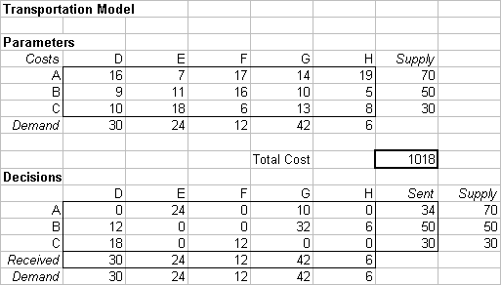

Exhibit 1. Spreadsheet format for the transportation example.

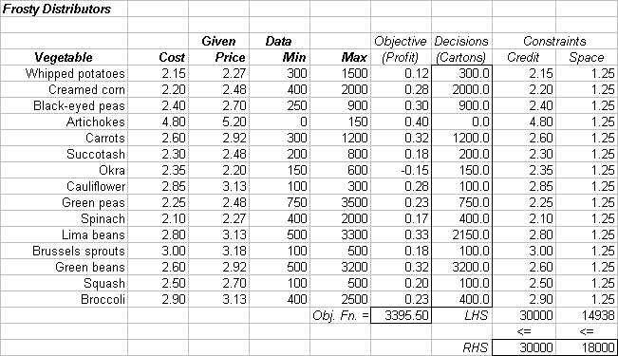
Exhibit 2. Spreadsheet format for the product portfolio example.

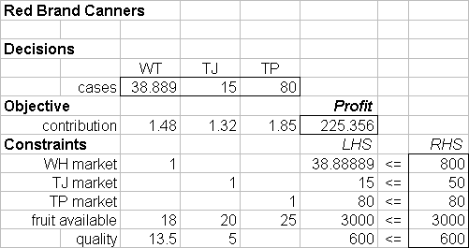

Exhibit 3. Spreadsheet format for the Red Brand example.

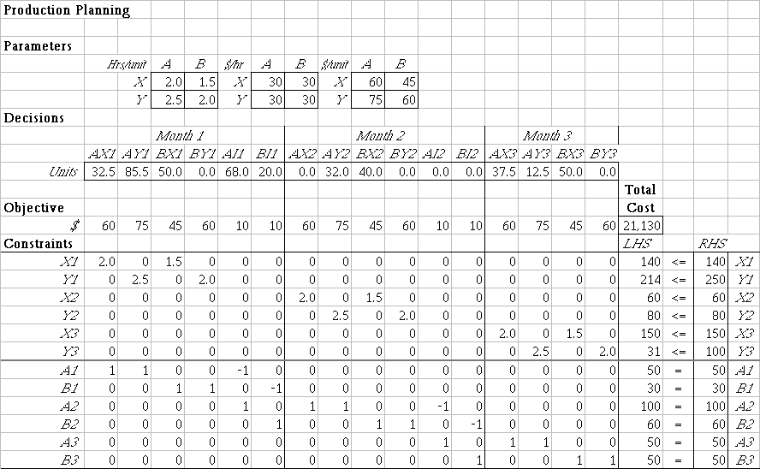
Exhibit 4. Spreadsheet format for the production planning example.

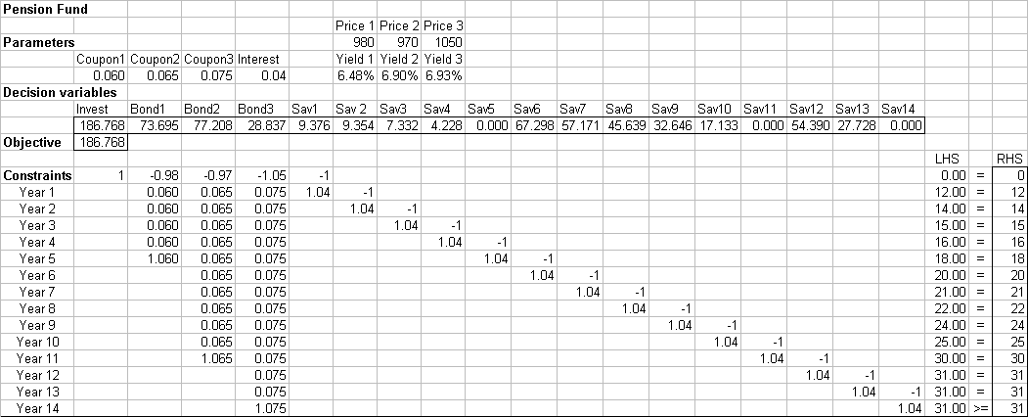
Exhibit 5. Spreadsheet format for the cash flow matching example.

Geoffrion, Arthur (1976). “The purpose of mathematical programming is insight, not numbers,” Interfaces, 7, 81-92.
See, for example, Daniel Fylstra, et al. (1998). “Design and Use of the Microsoft Excel Solver, ” Interfaces 28, 29-55.
This exhibit, and the others, can be found at the end of the document. They can also be downloaded as Excel files from the website http://mba.tuck.dartmouth.edu/patterns.
In this case the 100% rule would tell us only that the $29 marginal value holds for at least 8.7 units at the margin. For background on the 100% Rule, see Cliff Ragsdale (1998), Spreadsheet Modeling and Decision Analysis (Second Edition), p. 142.
Stanford Business Cases 1965, Stanford University, Palo Alto, CA; distributed by Harvard Business School Publishing as Case number 9-110-060.
A diagram of this process is available as a Powerpoint file, Tomato Diagram.
A diagram of this process is available as a Powerpoint file, Production Schedule Diagram.
Winston, Wayne (1998). Financial models using simulation and optimization (Chapter 14), Palisade Corporation, Newfield, NY.
A diagram of this process is available as a series of Excel worksheets, Iterative Solution.

